4CS015
FUNDAMENTALS OF COMPUTING
PORTFOLIO
Part-4

Name: -Rohit Sahani
Student Id: -NP02CS4A250027
NOTE: Please make sure you have written your command as well as the screenshot of the commands. Failure to do so will result in marks deduction.
Task 1 (Windows Command Line)
- Write a command to Create a directory "test"
Ans: MKDIR test
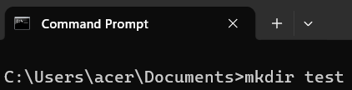

- Write the command to list all the directories/files inside the directory test
Ans: dir test

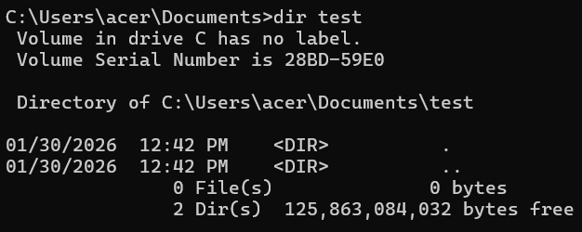

- Create a file "hello.txt" containing the word "Hello", inside the test directory.
Ans: echo hello > hello.txt

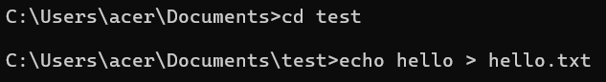

- Display the content of hello.txt in the command line.
Ans: type hello.txt
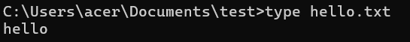

- Make directory test1 in the Desktop and copy hello.txt from test to test1
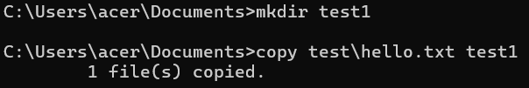

- Now delete the file hello.txt in the current directory
Ans: del hello.txt

- Write a command to display your current directory.
Ans: cd
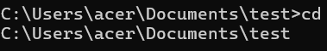

- Now rename the file to hello2.txt
Ans: del hello.txt

- Now navigate outside the directory test.
Ans: cd ..
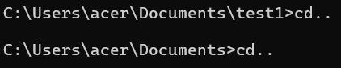

- Write the command to print the tree structure. It should look something like this:

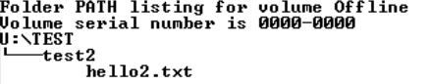
Ans: tree/f

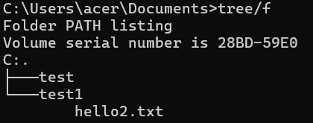

Task 2
Create the following directory structure and paste it after this picture. (15 marks):
Note: MYMODULES must be inside <your_name> directory.
Make a directory with your name on the desktop and navigate to the directory before you display the following structure.

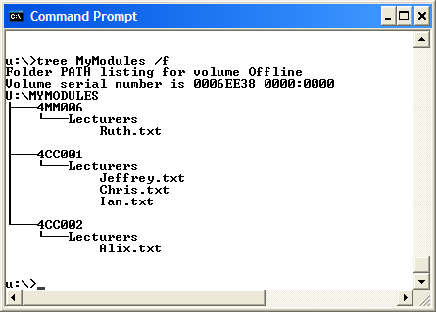
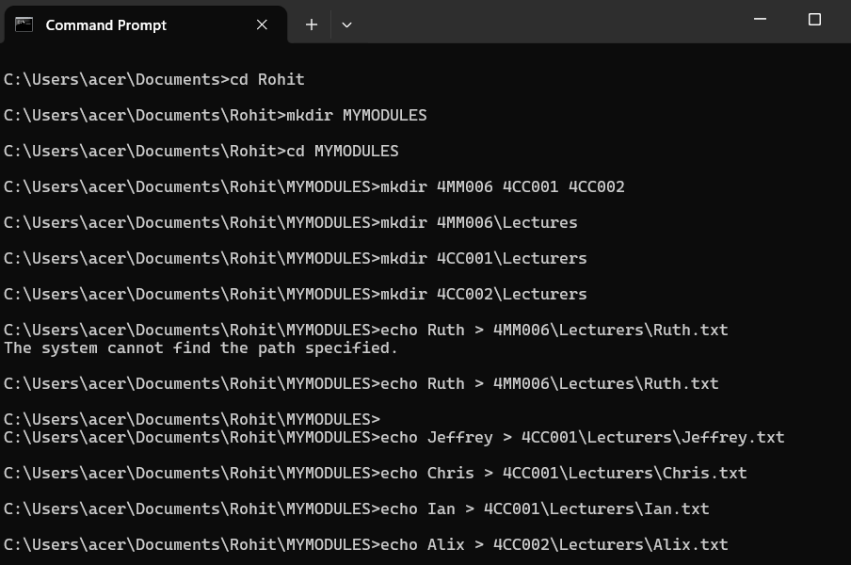

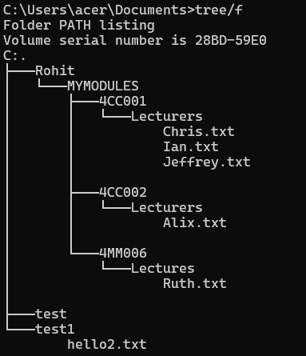
Task 3(Linux terminal) (10 marks)
- Write a command to Create a directory "test"
Ans: mkdir test
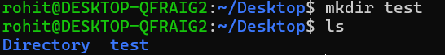

- Write the command to list all the directories/files inside the directory test
Ans: ls test

- Create a file "hello.txt" containing the word "Hello", inside the test directory.
Ans: test/hello.txt

- Display the content of hello.txt in the command line.
Ans: cat test/hello.txt

- Make directory test1 in the Desktop and copy hello.txt from test to test1
Ans: mkdir test1
Ans: cp test/hello.txt test1

- Now delete the file hello.txt in the current directory
Ans: rm test/hello.txt
- Write a command to display your current directory.
Ans: pwd

- Now rename the file to hello2.txt
Ans: mv hello.txt hello2.txt
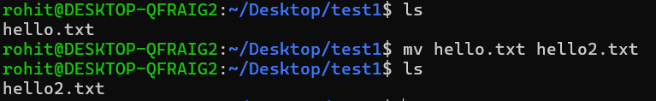

- Now navigate outside the directory test.
Ans: cd ..

- Write the command to print the tree structure.
Ans: tree
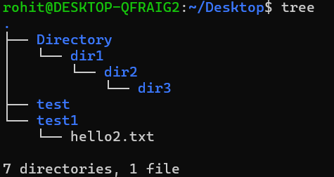

Task 4
Create the following directory structure (identical to the one that you created in Windows Command Prompt):
Note: MYMODULES must be inside <your_name> directory.
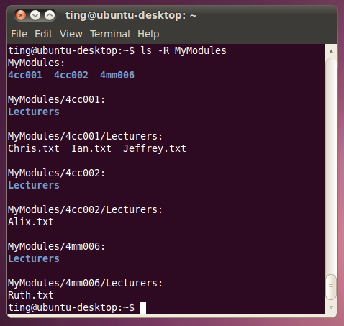
Ans:
cd ~/Desktop
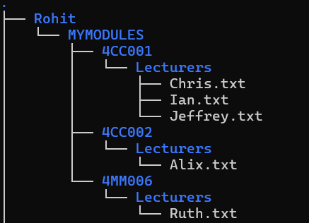
mkdir Rohit
cd Rohit
mkdir MYMODULES
cd MYMODULES
mkdir 4MM006 4CC001 4CC002
mkdir 4MM006/Lecturers
mkdir 4CC001/Lecturers
mkdir 4CC002/Lecturers
echo "Ruth" > 4MM006/Lecturers/Ruth.txt
echo "Jeffrey" > 4CC001/Lecturers/Jeffrey.txt
echo "Chris" > 4CC001/Lecturers/Chris.txt
echo "Ian" > 4CC001/Lecturers/Ian.txt
echo "Alix" > 4CC002/Lecturers/Alix.txt
tree

Task 5
Create a batch file (windows) YourNumber.bat from notepad (or your preferred text editor).
The batch file should create a directory structure similar to the one create for the first section of this assignment but the directory entries should be provided from an input request from the batch file itself.
You should be able to create a root directory and directory structure and populate it if required. The batch file program will ask for names (input directory names and file names) to be used and have some form of error checking (empty – incorrect character, length, etc.) You can add other features such as being able to edit the new structure from within the batch file program (find and change a directory name).
Run batch file from windows prompt: YourNumber.bat <enter>

- Menu
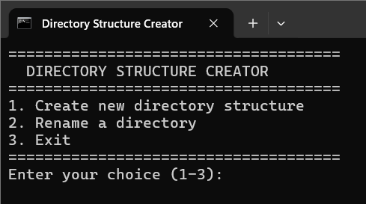

- Directory Structure
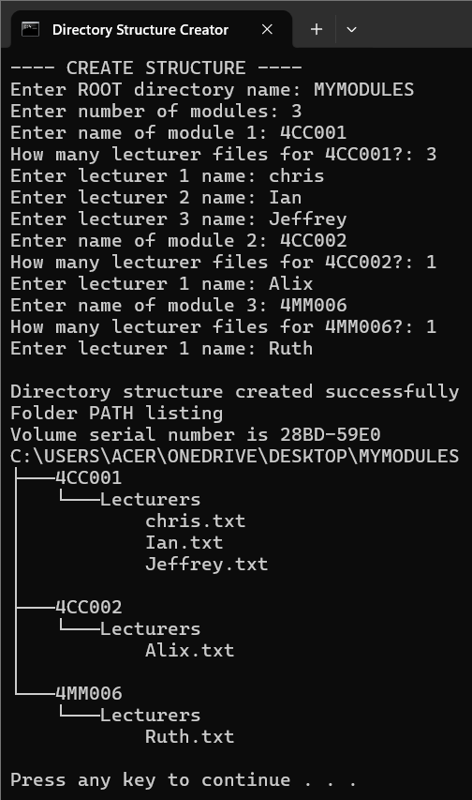

- Rename Directory
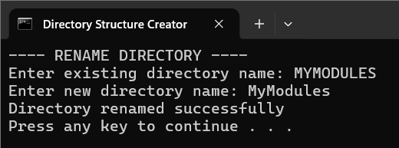

Batch file listing
@echo off
setlocal EnableDelayedExpansion
title Directory Structure Creator

:MENU
cls
echo =====================================
echo DIRECTORY STRUCTURE CREATOR
echo =====================================
echo 1. Create new directory structure
echo 2. Rename a directory
echo 3. Exit
echo =====================================
set /p choice=Enter your choice (1-3):

if "%choice%"=="1" goto CREATE
if "%choice%"=="2" goto RENAME
if "%choice%"=="3" exit
goto MENU

:CREATE
cls
echo ---- CREATE STRUCTURE ----

set /p ROOT=Enter ROOT directory name:
if "%ROOT%"=="" (
echo ERROR: Name cannot be empty
pause
goto MENU
)

echo %ROOT% | findstr /R "[\\/:*?<>|]" >nul
if not errorlevel 1 (
echo ERROR: Invalid characters used
pause
goto MENU
)

mkdir "%ROOT%" 2>nul || (
echo ERROR: Directory already exists
pause
goto MENU
)

cd "%ROOT%"

set /p MODULES=Enter number of modules:
if "%MODULES%"=="" goto ERRORINPUT

for /L %%i in (1,1,%MODULES%) do (
set /p MODNAME=Enter name of module %%i:
if "!MODNAME!"=="" goto ERRORINPUT
mkdir "!MODNAME!\Lecturers"

set /p FILECOUNT=How many lecturer files for !MODNAME!?:
for /L %%j in (1,1,!FILECOUNT!) do (
set /p FNAME=Enter lecturer %%j name:
echo !FNAME! > "!MODNAME!\Lecturers\!FNAME!.txt"
)
)

cd ..
echo.
echo Directory structure created successfully!
tree "%ROOT%" /f
pause
goto MENU

:RENAME
cls
echo ---- RENAME DIRECTORY ----
set /p OLD=Enter existing directory name:
set /p NEW=Enter new directory name:

if not exist "%OLD%" (
echo ERROR: Directory not found
pause
goto MENU
)

ren "%OLD%" "%NEW%"
echo Directory renamed successfully
pause
goto MENU

:ERRORINPUT
echo ERROR: Invalid input
pause
goto MENU

